A)

Schematic print

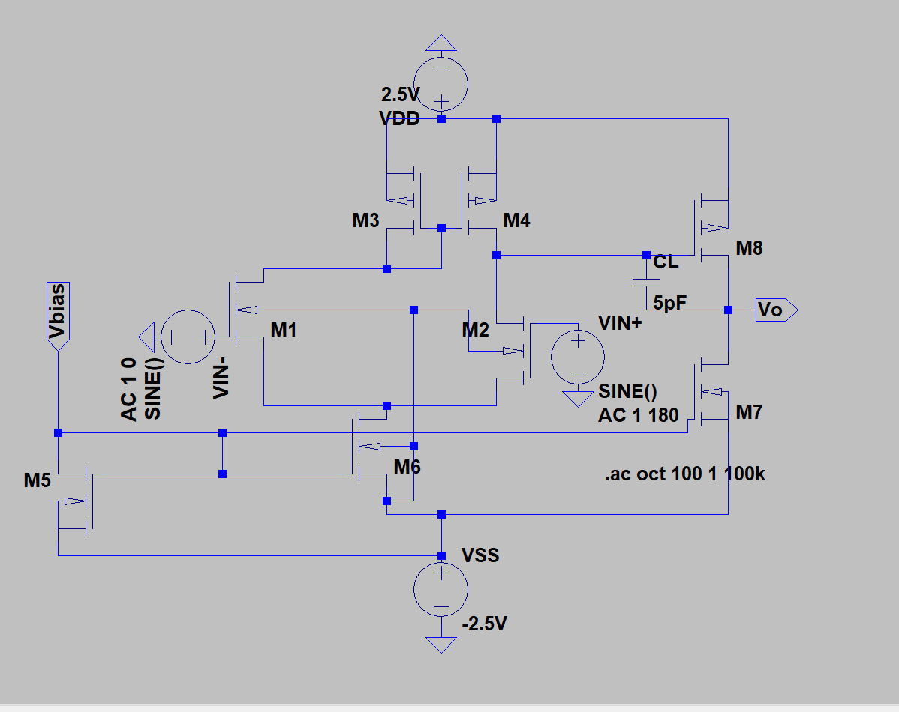

Schematic print in electric

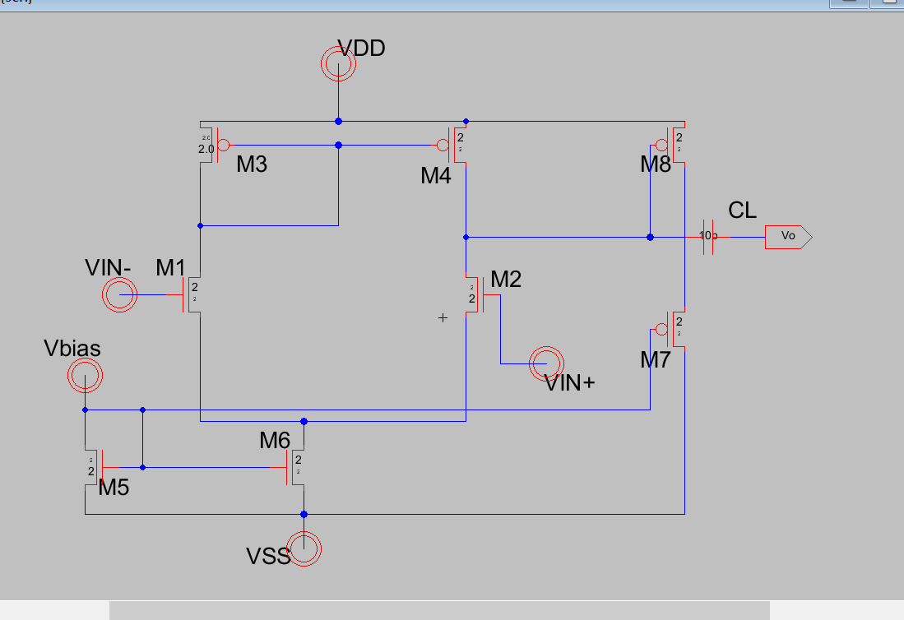

b)

the expansion technique:

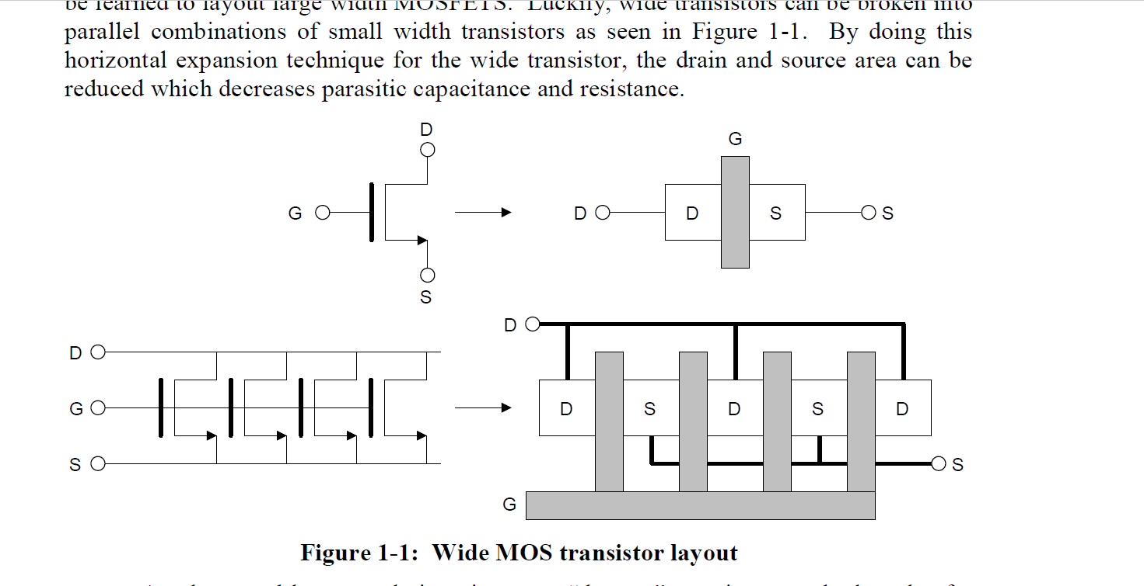

Rules in schematic diagram:

(+)

PMOS: series

NMOS: parallel

(\*)

PMOS: parallel

NMOS: series

Layout:

